TERM 2 2018 BALLINA ART SOCIETY
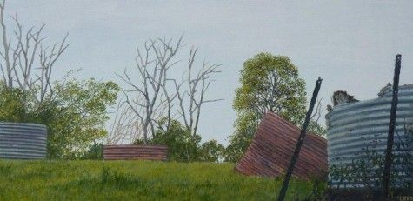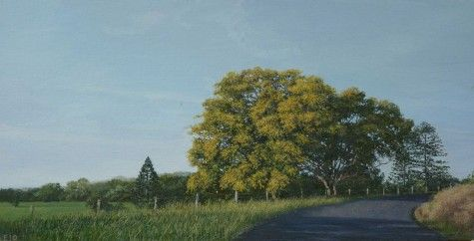
Term two with Tony promises to be exciting term with our regular realism Tutor, TONY LEITCH
Tony focusses on oil painting on canvas or board but is happy to help members in any medium. Tony’s background includes training in visual arts majoring in printmaking at Canberra School of Art. He has worked doing museum installations firstly as Head of Installations at the Australian National Gallery in the 1980's and then in the 1990's working in Museums in Saudi Arabia and China installing collections. Tony has lived in the Rosebank for the past 21 years and in 2008 started painting full time at his studio. He is currently setting up a gallery in Goonellabah.
Tony is a realism expert, and has a wonderful mastery of the landscapes in our hinterland. He also excels in portraits and has been selected to hang at the Northern Rivers Portrait prize in recent years. Tony loves to help us improve our works in preparation for the exhibition. As the silent auction category this year is “local themes and scenes”, Tony is the man to help make your picture special.
-------------------------------------------------------------------------------------------------------------------------------------APPLICATION FORM – TERM 2, 2018 TUTOR: Tony Leitch
THURSDAY CLASS: COMMENCING 3rd May- 21 June 2018^{h}
Term Fee: $130.00. Annual Membership Fee: $30.
Please forward a cheque, money order or direct deposit BSB 062 502 Account 00901131 Commonwealth Bank. If using last method of payment please inform TREASURER TINA FARROW at farrowtina@bigpond.com or call Helen 0408871820 so we get our numbers correct. Ensure you put your name on the money transfer so we also can tell it is yours. The class is limited to 28 participants. Please note the last session (21/6) is without a tutor and our meeting is held at 12pm.
EXHIBITION DATE is June 1,2,3 BALLINA ART SOCIETY INC. PO BOX 1475 BALLINA NSW2478
Name....................................................Phone....................................Email.............................................

